25.3 Editors - Properties Editor - Output Properties Tab
Detailed table of content 1
Output Properties Tab 5
Dimensions Panel 5
Presets 5
Resolution X / Y 5
Aspect X / Y 6
Render Region 6
Frame Start / End 6
Frame Step 6
Frame Rate 6
Time Remapping 6
Stereoscopy Panel 7
Workflow 7
Stereo 3D / Multiview 8
List of Cameras 8
Add / Remove / Rename 9
Suffix 9
Output Panel 9
File Path 9
Load File 9
File Format 10
Transparent 13
Options subpanel 13
Transparent subpanel 13
Encoding subpanel 14
Views Subpanel 14
Metadata Panel 17
Metadata Input 17
Include 17
Note 17
Burn into Image 17
Post Processing Panel 18
Pipeline 18
Dither 18

Detailed table of content

Detailed table of content
Detailed table of content 1
Output Properties Tab 5
Dimensions Panel 5
Presets 5
Resolution X / Y 5
Aspect X / Y 6
Render Region 6
Crop to Render Region 6
Frame Start / End 6
Frame Step 6
Frame Rate 6
FPS 6
Base 6
Time Remapping 6
Old 6
New 6
Stereoscopy Panel 7
Workflow 7
Stereo 3D / Multiview 8
List of Cameras 8
Resize handler 9
Search field 9
Add / Remove / Rename 9
Suffix 9
Output Panel 9
File Path 9
Load File 9
File Format 10
Image file formats 10
BMP 10
Color 10
Iris 10
Color 10
PNG 10
Color 10
Color Depth 10
Compression 10
JPEG 10
Color 10
Quality 10
JPEG 2000 10
Color 10
Color Depth 10
Quality 10
Codec 11
Cinema 11
Cinema (48) 11
YCC 11
Targa 11
Color 11
Targa Raw 11
Cineon 11
Color 11
DPX 11
Color 11
Color Depth 11
Log 11
Open EXR Multilayer 11
Color 11
Color Depth 11
Codec 12
Preview 12
Open EXR 12
Color 12
Color Depth 12
Codec 12
Z Buffer 12
Preview 12
Radiance HDR 12
Color 12
TIFF 12
Color 12
Color Depth 12
Compression 12
Movie file formats 12
AVI Jpeg 12
Color 12
Quality 13
AVI Raw 13
Color 13
FFmpeg video 13
Color 13
Transparent 13
Options subpanel 13
Saving 13
File Extensions 13
Cache Result 13
Image Sequence 13
Overwrite 13
Placeholders 13
Transparent subpanel 13
Transparent Glass 14
Roughness Threshold 14
Encoding subpanel 14
Presets 14
Views Subpanel 14
Individual 14
Stereo 3D 15
Stereo Mode 15
Stereo Mode Type Anaglyph 15
Anaglyph Type 15
Stereo Mode Type Interlace 15
Interlace Type 15
Swap Left/Right 15
Stereo Mode Type Side by Side 16
Cross Eyed 16
Squeezed Frame 16
Stereo Mode Type Top Bottom 16
Squeezed Frame 16
Metadata Panel 17
Metadata Input 17
Include 17
Note 17
Burn into Image 17
Font Size 17
Text Color 17
Background 18
Include Labels 18
Post Processing Panel 18
Pipeline 18
Compositing 18
Sequencer 18
Dither 18

Output Properties Tab

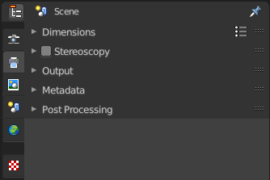
The Output properties contains all the settings to render the final image or movie. Most o fthe settings are the same for all three available render engines.

Dimensions Panel

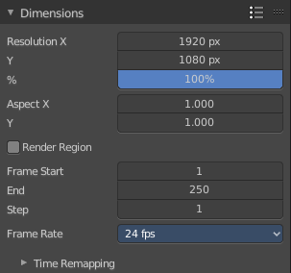
This panel contains the dimension settings.

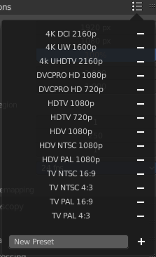
Presets
A list of dimension presets with the most common settings.
To add a new preset type in a new preset name into the edit box at the end of the list, and click at the + sign.
To remove a preset click at the - sign behind the name.
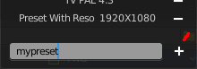

Resolution X / Y
The dimensions of the image in pixels.
%
Render the image in per cent of the original image. You can for example render in 200% of the resolution values. Or in 50%.

Aspect X / Y
The image aspect ratio. For anamorphic or non square pixel output.

Render Region
Activate render region for the output image.
There is a render region feature in the 3D view and in the Image editor where you can render a portion of the screen for preview purposes. Normally the output will always render the full image then, regardless of the render region. When you activate Render Region then the output will also render the render region only, and not the full image.

Crop to Render Region
Crop the output image to the size of the render region.

Frame Start / End
The start and end frame for an animation.

Frame Step
Number of frames to skip forward while playing the animation. With a value of 2 every second frame gets skipped.

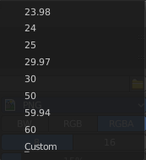
Frame Rate
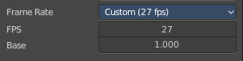
The output frame rate. When you choose custom then two more properties appears.

FPS
The custom frame per seconds value.

Base
Framerate base. A multiplier that makes it for example possible to set up 29,97 Frames instead of 30 for NTSC.

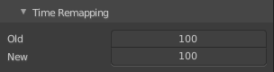
Time Remapping
Remap the length of an animation.

Old
The old length.

New
The new length.

Stereoscopy Panel

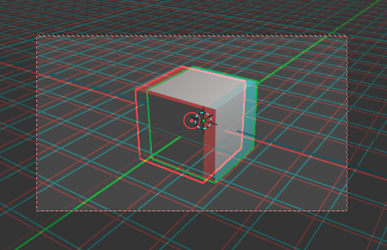
Allows you to render out stereoscopic images from the active camera. For the anaglyph images you need special stereoscopy glasses to see the 3D effect. And in case of the interlace method a 3d ready monitor and shutter glasses.

The anaglyph method is to create stereo images. The interlace method is mostly used in movies.

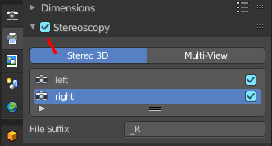
Workflow
Turn on Stereoscopy.

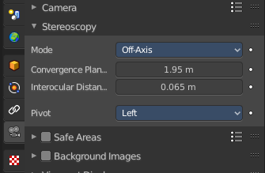
Select the Camera in the Outliner. In the Properties Editor choose the Object Data Properties tab (which should show a camera icon at this point), and open the Stereoscopy panel.
Change the Convergence Plane Distance to your needs. This can also be done in the 3D view with the handlers when you are in Camera view.
Interocular distance is the distance between the left and the right camera.
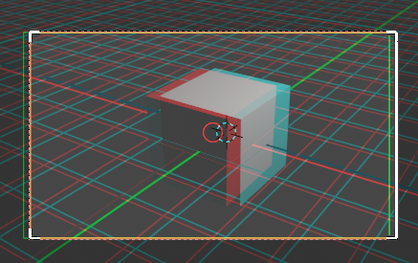

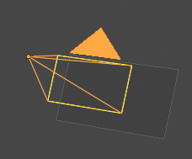
Outside of the camera view you will see this plane in front of the camera.
Adjust the plane to your needs. The plane is the reference point. Everything behind appears behind the focus. Everything before the plane appears before the focus.

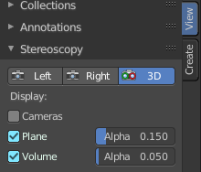
In the sidebar in the 3D view you will find further settings.
Turn on volume to see if the objects are inside of the volume.

Do a preview rendering, and adjust the settings if required.
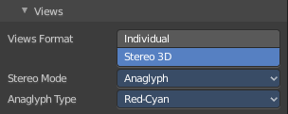
Go back to the Output tab to the Output panel. By activating stereoscopy here is a new section called Views. Here you can find further export settings.

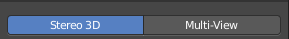
Stereo 3D / Multiview
The stereoscopy method. Stereo 3D uses two predefined virtual cameras. The camera settings gets inherited from the main camera.
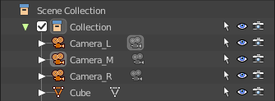
Multiview allows you to set up several cameras manually. You need to create every camera by hand. And you need to follow name conventions to get this to work. In the outliner give the cameras the suffix that you want to use in the list. Here three cameras with a suffix.

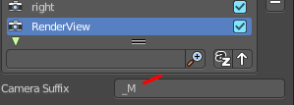
Now do the same in the list of cameras. Give every camera the same suffix than in the outliner. The camera name is not important. Important is the suffix. This is the identifier.

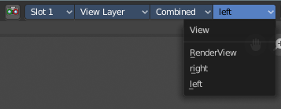
And in the render window you have now the render result of your three cameras.
Note that for stereoscopy just two cameras gets used for rendering the anaglyph or interlaced result. Usually the ones with suffix _L and _R. So our third camera does not influence the stereoscopic image here.

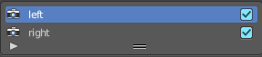
List of Cameras
The list of cameras. Note that with method Stereo 3D these cameras does not exist in the outliner. They are virtually created as child objects to the main camera that you use for rendering.
In this list you can choose the cameras to change the suffix.
The checkbox allows you to disable the cameras. Both options are just of interest for the multi-view setup. Normal stereoscopy setup does not require any further setup.

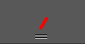
Resize handler
The resize handler allows you to resize the list.

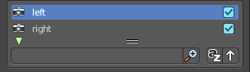
Search field
The triangle button down left allows you to open a search field.

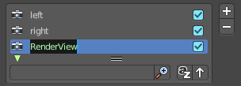
Add / Remove / Rename
Add adds a custom camera. Remove removes a custom camera. And custom cameras can be renamed by clicking at the name.
The camera names left and right can‘t be renamed, and you can‘t remove them from the list. Individual cameras can be renamed and removed.

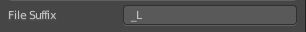
Suffix
The camera identifier. The suffix gets appended at the end of the single images of the camera. The left camera has the suffix _L , and the right camera has the suffix _R

Output Panel

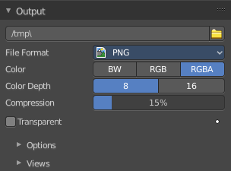
The file output settings.

File Path
The location to save rendered frames. Here you will find rendered animation sequences. For single images you can save out the result in the image editor.
When rendering an animation, the frame number is appended at the end of the file name with four padded zeros (e.g. image0001.png). You can set a custom padding size by adding the appropriate number of # anywhere in the file name (e.g. image_##_test.png translates to image_01_test.png).

This setting expands relative paths where a // prefix represents the directory of the current blend-file.

Load File
Here you can load an existing file to overwrite it. Or you can use it to load a file in a directory and rename it then to your destination file name.

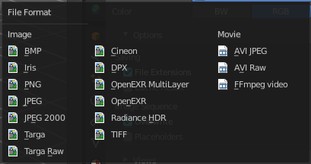
File Format
The output file format.
Each file format has some own settings.

Image file formats

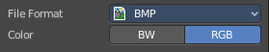
BMP

Color
The output color format. Black and white or rgb.

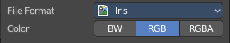
Iris

Color
The output color format. Black and white, rgb or rgba.

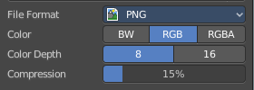
PNG

Color
The output color format. Black and white, rgb or rgba.

Color Depth
8 or 16 colors per channel.

Compression
The compression level.

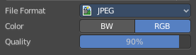
JPEG

Color
The output color format. Black and white, or rgb.

Quality
The jpeg quality.

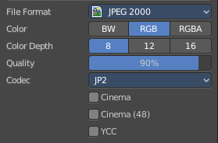
JPEG 2000

Color
The output color format. Black and white, rgb or rgba.

Color Depth
8, 12 or 16 colors per channel.

Quality
The jpeg quality.

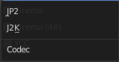
Codec
Which jpeg 2000 codec to use.

Cinema
Use OpenJpeg Cinema preset.

Cinema (48)
Use OpenJpeg Cinema (48) preset.

YCC
Save luminance / chrominance / chrominance channels instead of rgb channels.

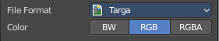
Targa

Color
The output color format. Black and white, rgb or rgba.

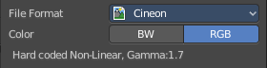
Targa Raw

Cineon

Color
The output color format. Black and white, or rgb.
Gamma of 1.7 and Non-Linear is hard coded.

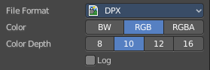
DPX

Color
The output color format. Black and white, rgb, or RGBA.

Color Depth
8, 10, 12 or 16 colors per channel.

Log
Convert to logarithmic color space.

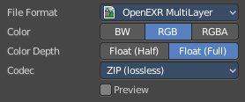
Open EXR Multilayer

Color
The output color format. Black and white, rgb, or RGBA.

Color Depth
Float half values or Float full values per channel.

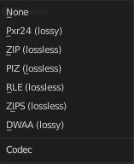
Codec
What codec to use.

Preview
When rendering animations, save Jpeg preview images into the same directory.

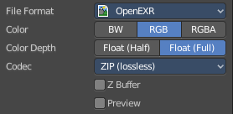
Open EXR

Color
The output color format. Black and white, rgb, or RGBA.

Color Depth
Float half values or Float full values per channel.

Codec
What codec to use.

Z Buffer
Save the Z Depth per pixel. 32 Bit unsigned int Z Buffer.

Preview
When rendering animations, save Jpeg preview images into the same directory.

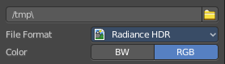
Radiance HDR

Color
The output color format. Black and white, or rgb.

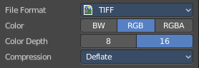
TIFF

Color
The output color format. Black and white, rgb, or RGBA.

Color Depth
8 or 16 bit per channel.

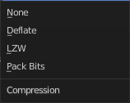
Compression
The compression method.

Movie file formats

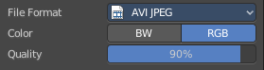
AVI Jpeg

Color
The output color format. Black and white, or rgb.

Quality
The jpeg quality.

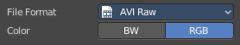
AVI Raw

Color
The output color format. Black and white, or rgb.

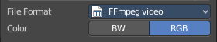
FFmpeg video

Color
The output color format. Black and white, or rgb.

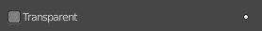
Transparent
Eevee and Workbench renderer. Render and export the result with transparent background.

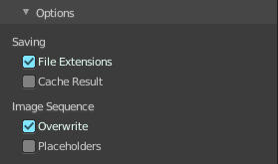
Options subpanel
Not all options are available for all file formats.

Saving

File Extensions
Adds the correct file extensions per file type to the output files.

Cache Result
Saves the rendered image and passes to a Multilayer EXR-file in temporary location on your hard drive. This allows the compositor to read these to improve performance, especially for heavy compositing.

Image Sequence

Overwrite
Overwrite existing files when rendering.

Placeholders
Create empty placeholder frames while rendering.

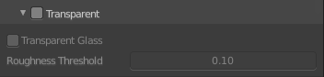
Transparent subpanel
Cycles only. Enable the rendering of transparent background.

Transparent Glass
Render glass with transparent background.

Roughness Threshold
For transparent transmission. Keep surfaces with roughness above the threshold opaque.

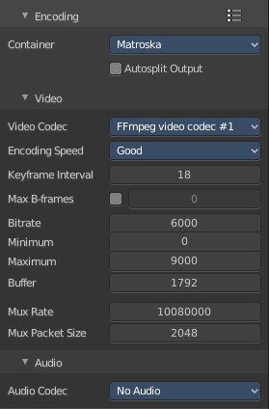
Encoding subpanel
FFmpeg video format only. The ffmpeg video encoding settings.
The settings should be in big parts self explaining. For further informations we suggest to consult the manual of the FFMpeg codec.

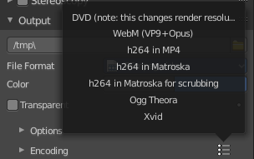
Presets
Some encoding presets. This set of preset is read only. You cannot add your own presets here.

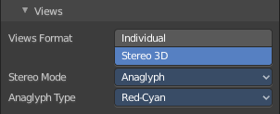
Views Subpanel
This subpanel just shows with Stereoscopy enabled.
Adjust the stereoscopy export settings. Note that this settings does not adjust what you view in the image editor. This settings influences what you save from the image editor then.

Individual
Save out single images from each camera when you save the result from the image editor. So for a stereoscopic image two images for the two cameras.

Stereo 3D
Save out the stereoscopic image as a single image when you save the result from the image editor.

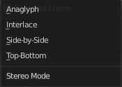
Stereo Mode
How to export the stereoscopic image with save as in the image editor. There are four methods available.

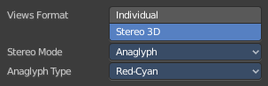
Stereo Mode Type Anaglyph
Render Views for left and right eyes as two differently filtered colors in a single image. You need anaglyph glasses to see the 3d effect.
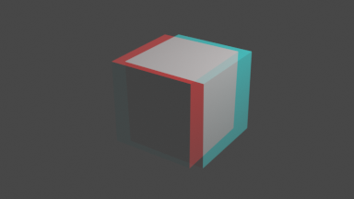

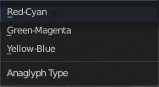
Anaglyph Type
The color model to display the graphics.

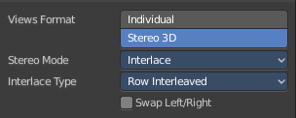
Stereo Mode Type Interlace
Render Views from left and right eyes interlaced into a single image. You need a 3D Ready monitor to see the stereo effect.
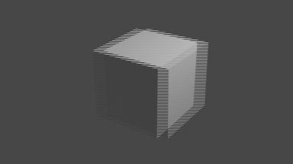

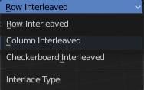
Interlace Type
The interlace type that you can choose.

Swap Left/Right
Swaps left and right camera view.

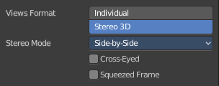
Stereo Mode Type Side by Side
Renders images of the two cameras side by side.

Cross Eyed
Swaps left and right camera view.

Squeezed Frame
Conbine both views in a squeezed image.

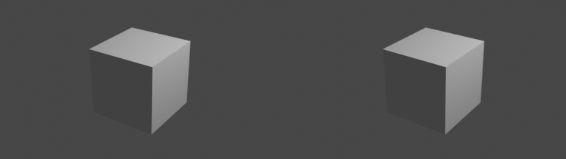

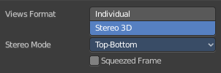
Stereo Mode Type Top Bottom
Renders images of the two cameras side by side.

Squeezed Frame
Conbine both views in a squeezed image.

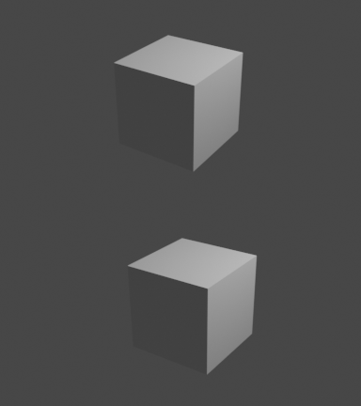

Metadata Panel
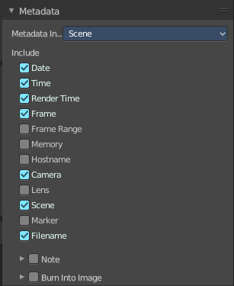
What metadata to include into the image or movie.

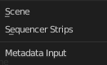
Metadata Input
Where to get the Metadata from.

Include
What Metadata to include.

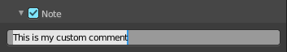
Note
Include a custom comment.

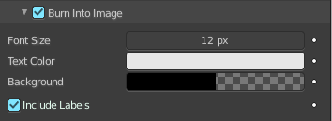
Burn into Image
Render the stamp info text into the image. The information is cluttered across the rendered image. Parts of it appears up left in the rendering. Parts down left, and parts down right.
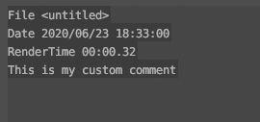
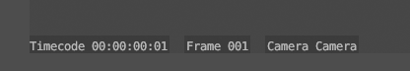
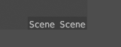

The props have decorators. This means this information can be keyframed. The font itself is the system font, and cannot be changed.

Font Size
The font size.

Text Color
The text color.

Background
The background color of the text.

Include Labels
Display stamp labels like "Camera" in front of camera name, etc.

Post Processing Panel

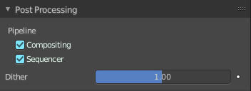
Enable Post Processing.

Pipeline

Compositing
Process the pipeline through the compositing in case compositing nodes are enabled.

Sequencer
Process the pipeline (and composited result) through the video sequence pipeline in case Sequencer strips exists.

Dither
Amount of dithering noise added to the rendered image to break up banding.
This prop has a decorator, and can be keyframe animated.

